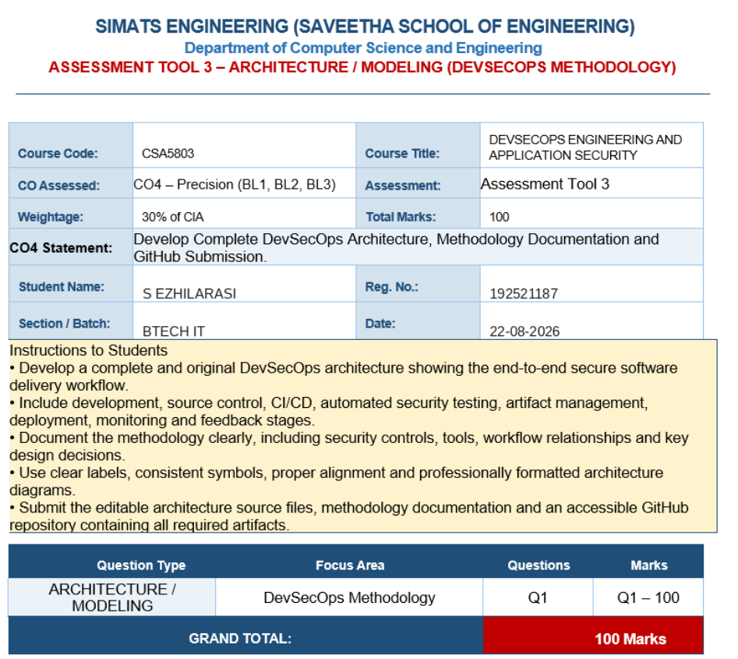
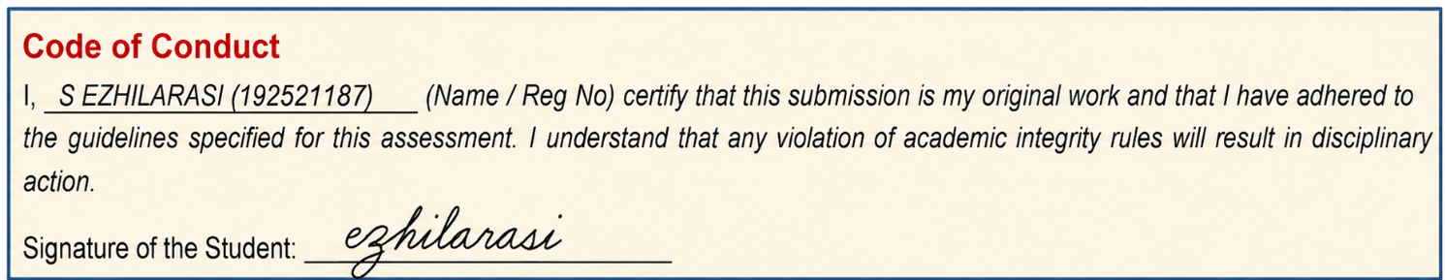

1. Executive Summary
This solution proposes an end-to-end DevSecOps methodology in which security is integrated throughout the software development lifecycle rather than added after deployment. The architecture combines GitHub-based source control, automated CI security gates, software composition analysis, secret detection, artifact management, Infrastructure as Code, GitOps deployment, runtime protection, centralized observability and continuous feedback.

2. DevSecOps Architecture
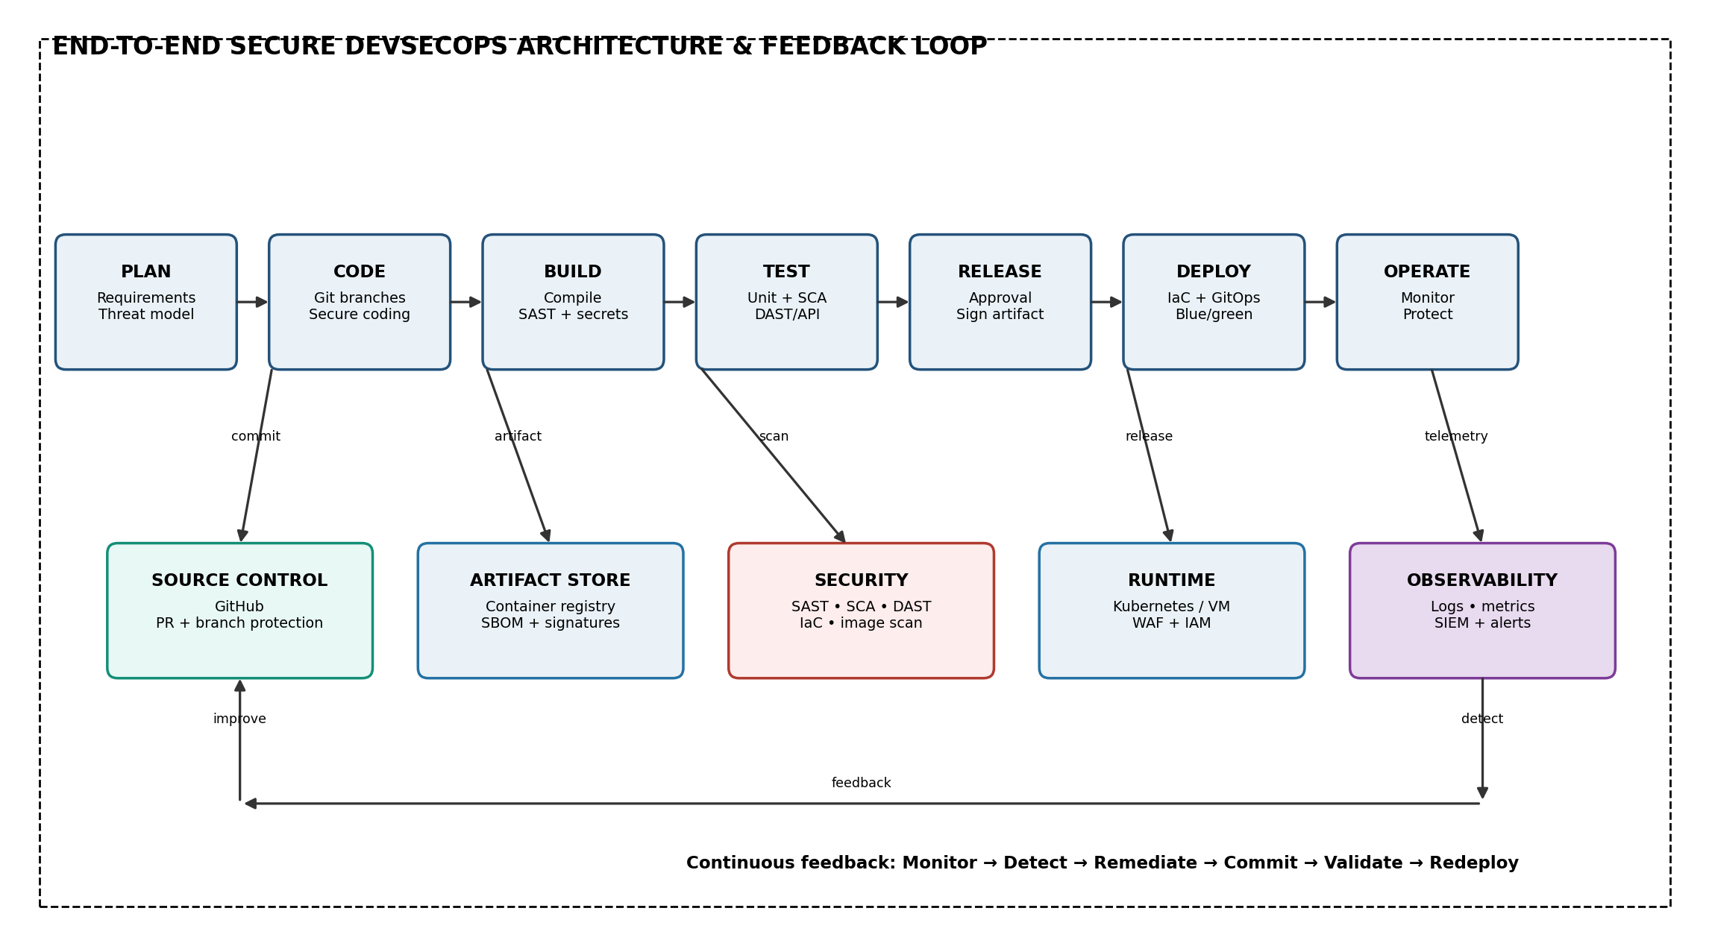
Figure 1. End-to-end DevSecOps lifecycle with security controls and continuous feedback.
The architecture follows a secure CI/CD and GitOps model. Developers commit to protected branches, automated checks validate the change, trusted artifacts are created and signed, infrastructure is provisioned through IaC, deployment state is managed through GitOps, and runtime telemetry feeds security and engineering teams.

3. Methodology: Secure Software Delivery Lifecycle
Stage | Activities | Security Outcome
Plan | Define functional/security requirements, identify assets, perform threat modeling, establish security acceptance criteria. | Security is verified before the workflow moves to the next controlled stage.
Code | Use protected Git branches, peer review, secure coding standards and pre-commit secret checks. | Security is verified before the workflow moves to the next controlled stage.
Build | Compile/package reproducibly; run SAST, secret scanning, dependency checks and IaC validation. | Security is verified before the workflow moves to the next controlled stage.
Test | Run unit/integration tests, SCA, DAST/API security tests and security regression tests. | Security is verified before the workflow moves to the next controlled stage.
Release | Generate SBOM, scan/sign artifacts, verify quality/security gates and obtain required approval. | Security is verified before the workflow moves to the next controlled stage.
Deploy | Use Terraform/IaC and GitOps; deploy only approved, traceable versions to controlled environments. | Security is verified before the workflow moves to the next controlled stage.
Operate | Apply IAM, WAF, runtime controls, backups and patching while continuously monitoring health and security. | Security is verified before the workflow moves to the next controlled stage.
Monitor & Feedback | Collect logs/metrics/traces, detect incidents, remediate vulnerabilities and feed lessons back into planning. | Security is verified before the workflow moves to the next controlled stage.

4. Source Control and Branching Strategy
- Use GitHub as the single source of truth for application code, IaC, pipeline definitions and deployment manifests.
- main branch is protected and cannot be changed directly by normal developers.
- Developers work on feature/* branches and submit pull requests for review.
- Require at least one or two reviewers for security-sensitive changes depending on project policy.
- Require all mandatory CI checks to pass before merge.
- Use CODEOWNERS for critical security, infrastructure and workflow files.
- Enable signed commits/tags where practical and retain a complete audit history.

5. CI/CD Security Pipeline
Pipeline Stage | Tool / Check | Purpose | Gate
Pre-commit | Secret scanner / lint | Catch secrets and coding errors early | Block obvious secrets
SAST | Semgrep/SonarQube or equivalent | Find insecure source patterns | Block critical findings
SCA | Dependency scanner | Find vulnerable third-party packages | Block critical CVEs
IaC Scan | Checkov/Trivy or equivalent | Find insecure infrastructure configuration | Block critical misconfiguration
Unit/Integration Tests | Automated tests | Verify functional correctness | Required pass
Build | Reproducible container build | Create release artifact | Only from approved commit
Image Scan | Trivy/registry scanner | Find OS/library vulnerabilities | Block critical vulnerabilities
SBOM | CycloneDX/SPDX | Record component inventory | Required for release
DAST/API | OWASP ZAP or equivalent | Find runtime web/API issues | Block high/critical issues
Sign & Publish | Cosign/signing + registry | Ensure artifact integrity | Only signed artifacts

6. Artifact Management and Supply-Chain Security
- Store container images/packages in a private registry with role-based access.
- Generate an SBOM for every release to maintain a software component inventory.
- Scan images and dependencies before publication and periodically after release.
- Sign approved artifacts and verify signatures during deployment.
- Pin important dependencies and use trusted base images.
- Retain provenance information linking an artifact to its Git commit and pipeline run.
- Reject unsigned, unverified or policy-violating artifacts from production.

7. Infrastructure as Code (IaC)
Terraform is proposed as the IaC example, although the same methodology can be implemented with another approved IaC tool.
- Define network, IAM, compute, database, storage, monitoring and security resources as code.
- Separate reusable modules from environment-specific configuration.
- Run formatting, validation and security policy checks in CI before merge.
- Use separate credentials/state for development, staging and production.
- Protect production state and require reviewed pull requests for infrastructure changes.
- Never store cloud passwords, API keys or private keys in the repository.

8. GitOps Deployment Methodology
- CI validates the source code and creates a signed artifact.
- The approved image/version is recorded in the GitOps repository.
- A pull request updates Helm/Kubernetes manifests or equivalent desired-state configuration.
- Reviewers approve the deployment change.
- Argo CD or Flux detects the repository state and reconciles the target environment.
- The controller deploys the approved version using its least-privilege service account.
- Drift from Git is detected and corrected according to the configured policy.
- Deployment events are logged and sent to monitoring/SIEM.

9. IAM and Security Controls
Identity | Access | Authentication | Controls
Developer | Feature branches, test resources | SSO + MFA | Least privilege
Reviewer | PR approval | SSO + MFA | CODEOWNERS + audit
CI/CD Service | Build, scan, publish | Short-lived token | Scoped permissions
GitOps Controller | Deploy approved manifests | Service identity | Namespace/resource restrictions
Platform Admin | Infrastructure administration | MFA + privileged access | Approval + audit
Auditor | Read-only logs/reports | SSO + MFA | No modification rights
- Apply RBAC and least privilege to human and machine identities.
- Use MFA for privileged access.
- Prefer short-lived credentials and workload identities.
- Rotate secrets and keys regularly.
- Record authentication, authorization and administrative events.
- Perform periodic access reviews and remove unused permissions.

10. Monitoring, Logging and Feedback
- Collect CI/CD, GitHub, infrastructure, application, WAF, IAM and deployment logs.
- Centralize security events in a SIEM with restricted access.
- Monitor metrics such as deployment failures, latency, error rate, resource use and vulnerability counts.
- Create alerts for repeated login failures, privilege changes, suspicious deployments and critical security findings.
- Use the feedback loop to create remediation tickets, update code/policies and redeploy through the same controlled pipeline.
- Protect logs against unauthorized deletion or modification and maintain appropriate retention.

11. Security Testing Strategy
Testing Type | When | Example Objective
SAST | Every PR/build | Find insecure coding patterns
Secret Scanning | Every commit/PR | Prevent credential leakage
SCA | Every build | Detect vulnerable dependencies
IaC Security | Every infrastructure PR | Detect insecure cloud/Kubernetes configuration
Container Scan | Every image | Detect vulnerable packages/configuration
DAST/API | Staging/pre-release | Detect runtime web/API vulnerabilities
Penetration Test | Periodic / major release | Validate defense-in-depth
Recovery Test | Periodic | Validate backup restoration

12. Environment Promotion Model
- Development: fast feedback, isolated resources and broad automated testing.
- Staging: production-like environment used for DAST, integration and release validation.
- Production: protected environment where only approved, signed artifacts and reviewed GitOps changes are deployed.
- Promotion is traceable from production deployment back to the Git commit, artifact digest and CI run.

13. Incident Response Methodology
- Detect: SIEM, monitoring or security tooling raises an alert.
- Triage: determine affected identity, workload, artifact or infrastructure.
- Contain: revoke credentials, isolate workloads or block malicious traffic as appropriate.
- Eradicate: remove malicious code/configuration, patch vulnerabilities and rotate secrets.
- Recover: redeploy a known-good signed artifact through GitOps and restore data if required.
- Review: preserve evidence, document root cause and update tests/policies to prevent recurrence.

14. Documentation Methodology
- Maintain README.md containing project purpose, architecture, setup and deployment instructions.
- Maintain ARCHITECTURE.md describing components, trust boundaries, data flows and design decisions.
- Maintain SECURITY.md covering threat model, security controls, vulnerability reporting and secure development practices.
- Maintain DEPLOYMENT.md covering environments, IaC, GitOps flow and rollback procedures.
- Maintain a changelog/release notes linking versions to important changes.
- Keep diagrams in editable Draw.io/DiagrammeR source form alongside exported PDF/PNG versions.

15. GitHub Repository Structure
README.md
ARCHITECTURE.md
SECURITY.md
DEPLOYMENT.md
docs/architecture.drawio
docs/methodology.md
docs/threat-model.md
src/
tests/
infra/
deploy/
.github/workflows/
policies/
sbom/

16. GitHub Submission Checklist
- Repository is accessible to the evaluator using the submitted link.
- Architecture source files are editable and included.
- Methodology documentation is complete and synchronized with the final architecture.
- IaC/configuration files are included without passwords, API keys or private secrets.
- CI/CD workflow files are included and security checks are visible.
- Final PDF report contains the architecture diagrams and explanations.
- Repository structure is organized and all required artifacts are present.
- README explains how to run, test and understand the project.

17. Key Design Decisions
Decision | Reason | Security/Operational Benefit
Git as source of truth | Provides history and reviewability | Auditable changes and easy rollback
GitOps deployment | Separates build from production reconciliation | Controlled, repeatable deployment
Automated security gates | Find issues before release | Reduces vulnerable production changes
Signed artifacts | Proves artifact integrity | Reduces supply-chain tampering
Least-privilege IAM | Limits permissions | Reduces blast radius
Centralized SIEM | Correlates events | Faster detection and investigation
IaC | Reproducible infrastructure | Consistent and reviewable environments

18. Conclusion
The proposed DevSecOps methodology provides an end-to-end secure software delivery model from planning and coding through build, testing, release, deployment, operation and feedback. Security is continuously validated using SAST, SCA, secret scanning, IaC scanning, image scanning and DAST. GitHub provides source control and auditability, while GitOps provides controlled deployment and drift management. IAM, least privilege, artifact signing, centralized monitoring and documented incident response complete the security architecture.

